

COURSEWORK COVER PAGE
Module Code/Title: | LD4019 Algorithms and Programming Fundamentals
Module Tutor Name: | Aamir Majeed [AM], Rao Ali [RA]
Student Name (ID): | Beren Nadir(w24064680)
Programme of Study: | BSc Computing Level 4
Coursework Title: | Final Report
Word count: | 3682
Submission Instructions:
- Name your submission using the name convention, LD4019_<your tutor initial>_<your programme> <level>_<your id><name>.docx, eg LD4019_AM_BSC4_w24012345John.docx is a submission for the student of MSc Computing & Technology (Sep Intakes) attending Aamir Majeed’s session.
- Submit to Bb on or before 16:00, 15 May 2025

Declaration of that the submission is your own work
I confirm that:
☐ This assignment submission is my own, independent work.
☒ I have referenced the sources of information, ideas, and quotations that I have used in this submission and listed my sources in a bibliography.
☐ I have submitted the supporting documentation I have been asked for (e.g., notes, plans, etc - refer to your assessment brief).

Declaration of the Use of AI tool:
EITHER
☐ I have not used AI at any point in preparing this assignment.
OR
☒ I have used AI tools (including, but not limited to ChatGPT) to help me (select all that apply):
☐ Generate initial ideas in response to the question.
☐ Develop my structure.
☒ Generate ideas for examples / sources.
☐ Provide feedback and suggestions for improvement on my content.
☐ Edit and improve my spelling and grammar.
☐ Other: please explain: _________________________________________________________

☐ I have NOT used AI to generate whole sentences, paragraphs, sections, or the whole of this assignment and I understand that this would be considered academic misconduct.

Your signature: | Beren Nadir | Date: | 12/05/2025

Report on Data Algorithms and Programming Fundamentals
Student ID: w24064680
Student Name: Beren Nadir

Table of Contents
1. Introduction 4
1.2 The Five Key Variables 4
2. Pseudo codes & flowcharts 5
2.1 ADD_BOOK(in Pseudo Codes) 5
ADD_BOOK (in FlowCharts): 6
2.2 BORROW_BOOK 7
BORROW_BOOK (in FlowCharts): 7
2.3 RETURN_BOOK 9
RETURN_BOOK (in FlowCharts): 9
3. Implementation of the Codes 11
3.1 Adding a Student/Staff: 11
3.2 Adding a Book: 12
Output of addBook function: 12
3.3 Borrowing a Book: 13
Output of borrowBook function: 13
3.4 Returning the Book and Calculating the fine: 14
Output of returnBook and calculateFine function: 15
3.5 Removing Book & Removing Student 15
Output of removeBook and removeStudent function: 16
3.6 Listing the Books and their Borrowing Status 17
Output of listBooks() function: 17
3.7 Search for Students and Books by typing 18
Output of searchAUser & searchBookByTitle() function: 19
3.8 Backing up and Restoring the Data 19
Output of backup_data() & restore_data() function: 20
Student’s Interface: 21
Data Loading Routine (users.txt & library_data.txt): 22
IMPORTANT(Data path)! 23
4. Critics of Programme 23
Privacy & data use. 23
Fair access. 23
Data loss & integrity. 23
Transparency of fines. 24
Ethical handling of errors. 24
Future improvements. 24
References 24

- Introduction
For this programming project, I built a basic Library Management System using Python [6]. The aim was to enable school library staff and students to check out and return books more conveniently. Managing book inventories, tracking borrowed items, updating user accounts, and computing late book return fees are main duties of the program. In the end, I sought for a simple, practical tool to speed up normal library activities and reduce manual work.
1.1 Project Planning and Management
Early in the project, determining precisely what library staff and students would want from such a system required great effort [6]. By offering a brief summary of the duties, including tracking books, checking and returning them, managing user accounts, and determining penalties, I attempted to be clear. Any misunderstanding might lead to unnecessary complexity or the omission of crucial information, therefore I started with particular criteria.
My system's overall architecture was then designed by me to comprise data storage and maintenance. Given the project's size, I chose straightforward file management techniques like text files since they are practical and simple to use [2]. Coding struck me as quite challenging, particularly with regard to file management. The data, for example, might first be misread or written. But regular testing and debugging would help me to fix these issues.
Examining this approach was also rather crucial. Testing revealed many little issues including logical mistakes in the borrowing process and faulty user input control. These little mistakes helped me to see how vital comprehensive testing is [6]. This initially delayed my growth, so if I were to work on this project again, I would be far more careful with unexpected or erroneous inputs.
I also began to understand the need of data backup. To guarantee no vital data is accidentally lost, I created a backup and recovery system [4]. Though it wasn't what I had in mind, as it developed it became clear it was totally required.
All things considered, this project showed me a great deal regarding efficient task management and the need of careful planning and testing. Though there were surely some areas where I could have done better, such as being more ready for unanticipated events, the experience greatly deepened my knowledge of software development.

The Five Key Variables

- userId (string): This is the user’s library card number. I store it as text, not a number, because I never have to add or subtract it. Treating it like plain text makes comparing IDs a lot simpler.

- borrowedBooks (list): People often take home more than one book. A list lets me drop in a new book ID or remove one the moment a reader returns it. Quick and easy.

- dueDate (float): Python spits out time stamps as big floating-point numbers. I just keep them that way. Then I can tell in one line if a book’s overdue.

- borrowerInfo (dictionary): I bundle a patron’s details name, email, phone into a single dictionary. When I need, say, the email, I grab it straight from there instead of digging through a jumble.

- status (string): A book is either “available” or “borrowed.” Two plain words say everything I need no fancy codes, no extra fuss.

Pseudo codes & flowcharts

2.1 ADD_BOOK(in Pseudo Codes)

START
Prompt staff for book name, author, genre, and page count
Generate a new book ID (current number of books + 2000)

Create a book record:
bookId ← new ID (string)
bookName ← staff input
author ← staff input
genre ← staff input
pages ← pages as integer
status ← "available"
borrowedBy ← None
dueDate ← None
borrowerInfo ← empty dictionary

Store the record in books dictionary
Write updated books dictionary to file
Display “Book added” message with its ID
END

ADD_BOOK (in FlowCharts):
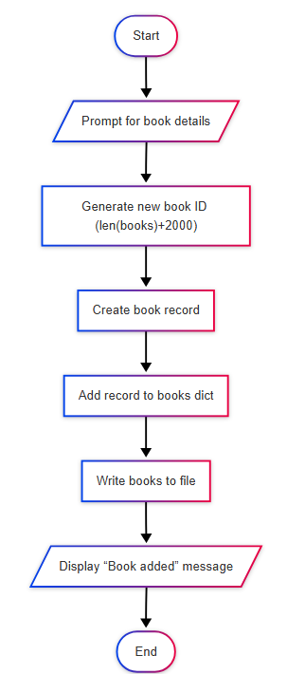
Figure 1: ADD_BOOK (Source : Created by me)

2.2 BORROW_BOOK

START
Display all books whose status is "available"
Prompt user for the book ID to borrow

IF book ID is not found OR book status ≠ "available" THEN
Display “Book not available”
END
ELSE
Update selected book:
status ← "borrowed"
borrowedBy ← current userId
dueDate ← current time + 7 days
borrowerInfo ← user’s full record

Append book ID to user’s borrowedBooks list
Write updated books dictionary to file
Display confirmation with human-readable due date
ENDIF
END

BORROW_BOOK (in FlowCharts):

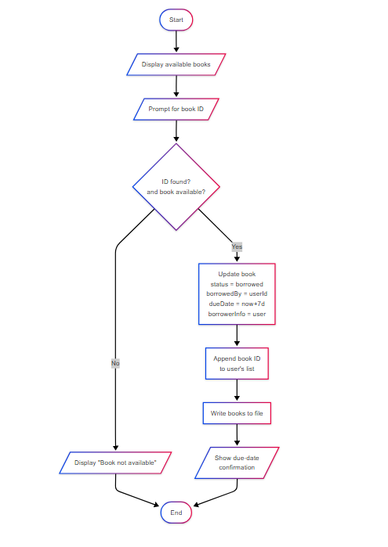

Figure 2: BORROW_BOOK (Source: Created by me)

2.3 RETURN_BOOK

START
Prompt user for the book ID to return

IF book ID not in books OR books[bookId].borrowedBy ≠ current userId THEN
Display “You did not borrow this book”
END # exit routine early
ELSE
Calculate overdueDays ← (current time − books[bookId].dueDate) / 86 400
IF overdueDays > 0 THEN
fine ← overdueDays × 1 # one unit per day late
ELSE
fine ← 0
ENDIF

Reset selected book:
status ← "available"
borrowedBy ← None
dueDate ← None

Remove book ID from user’s borrowedBooks list
Write updated books dictionary to file
Display “Book returned” message and the fine amount
ENDIF
END

RETURN_BOOK (in FlowCharts):

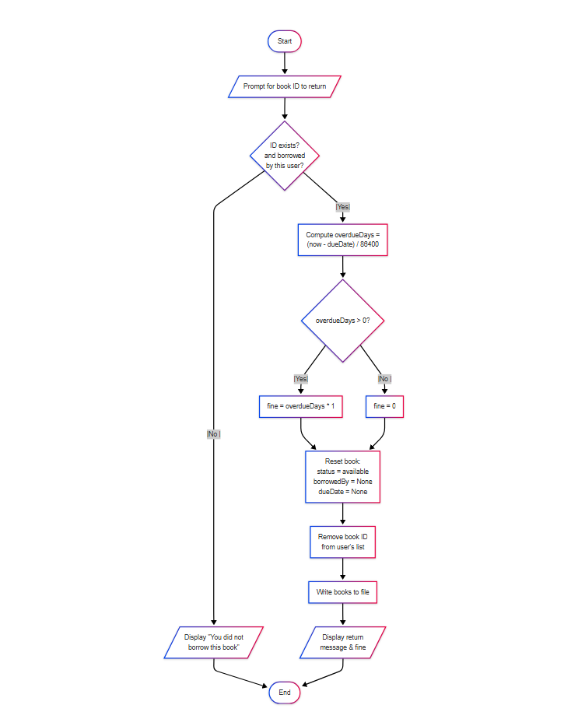

Figure 3: BORROW_BOOK (Source: Created by me)

Implementation of the Codes

3.1 Adding a Student/Staff:
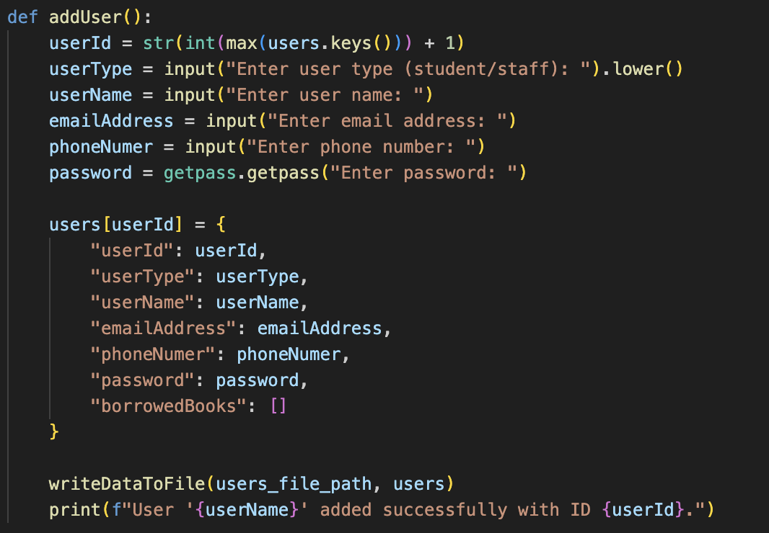

Figure 4: addUser (Source: Created by me)

The addUser() routine is the libraries “new-member” gateway. When a staff member selects this option, the program asks a handful of plain language questions what type of user, their name, email, phone, and a password that’s collected securely with getpass. It then looks at the existing users dictionary, finds the highest ID already in use, and simply adds one, it’s guaranteeing the new account number is unique without any fancy database logic. All the responses are packed into a tidy dictionary entry and dropped into the in-memory users collection. Finally, writeDataToFile() flushes the updated data straight to users.txt, so the record survives the next run, and a confirmation line appears on the screen to reassure the librarian that the signup which actually worked.
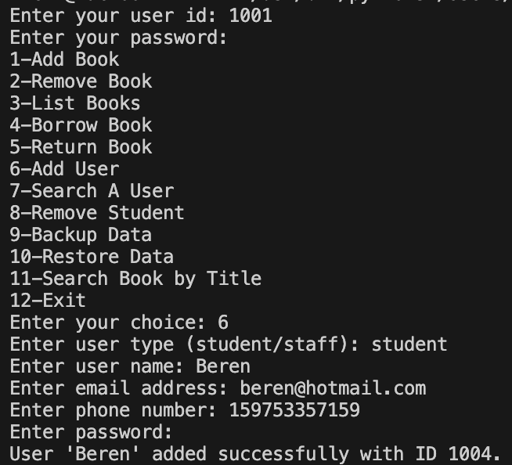
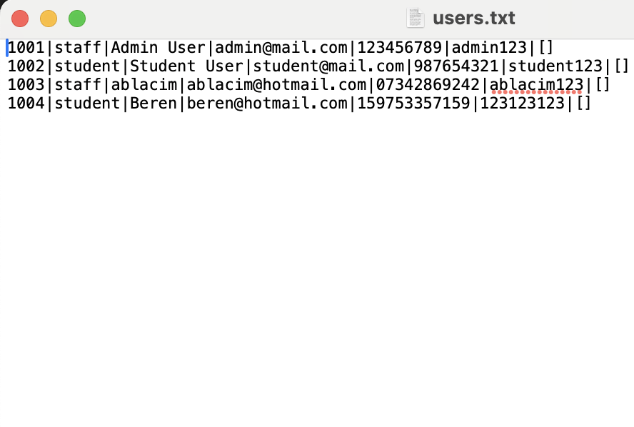
Output of addUser function:
(Logged in as User(staff) and added a new student)

3.2 Adding a Book:

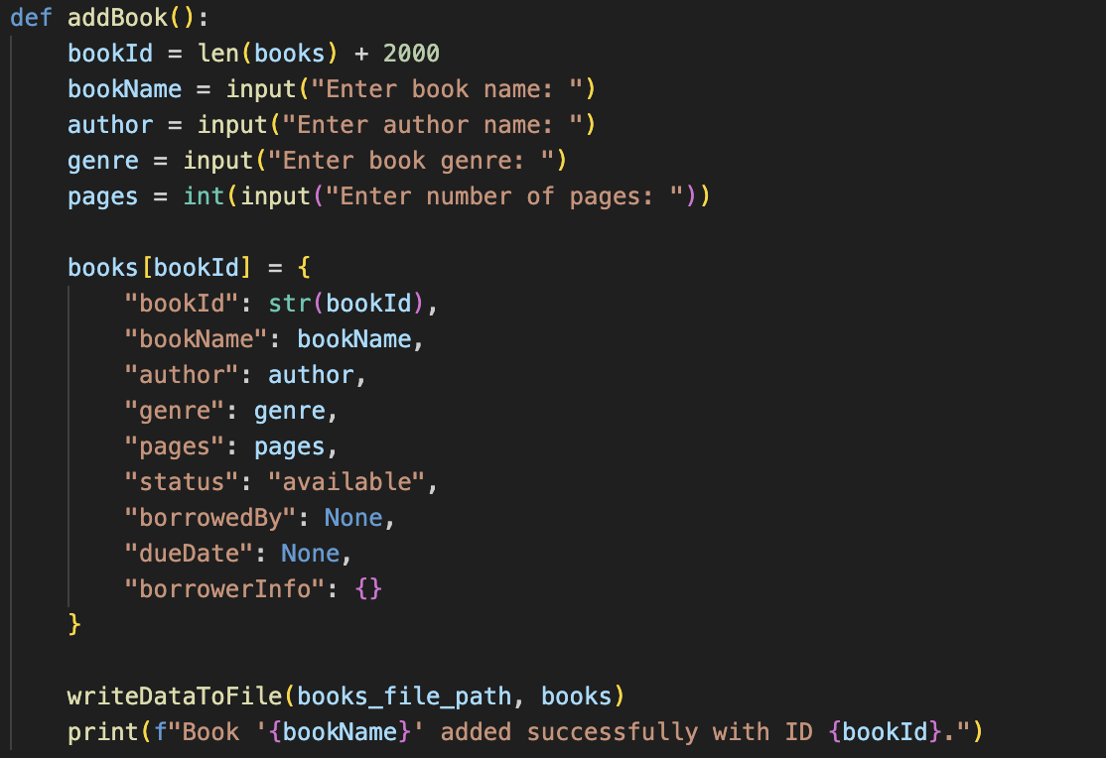

Figure 5: addBook (Source: Created by me)

Think of addBook() as the quick-add button for new titles. The code picks a fresh ID by counting how many books we already stored and then adding 2000, so book numbers don’t clash with any user IDs. After that, it just chats with the librarian asks for the title, author, genre, and how many pages. Those answers get packed into one tidy record, marked available by default, and dropped into the books list. We hit writeDataToFile() so the info sticks on disk right away, then show a short “book added” note to prove the job’s done.

Output of addBook function:
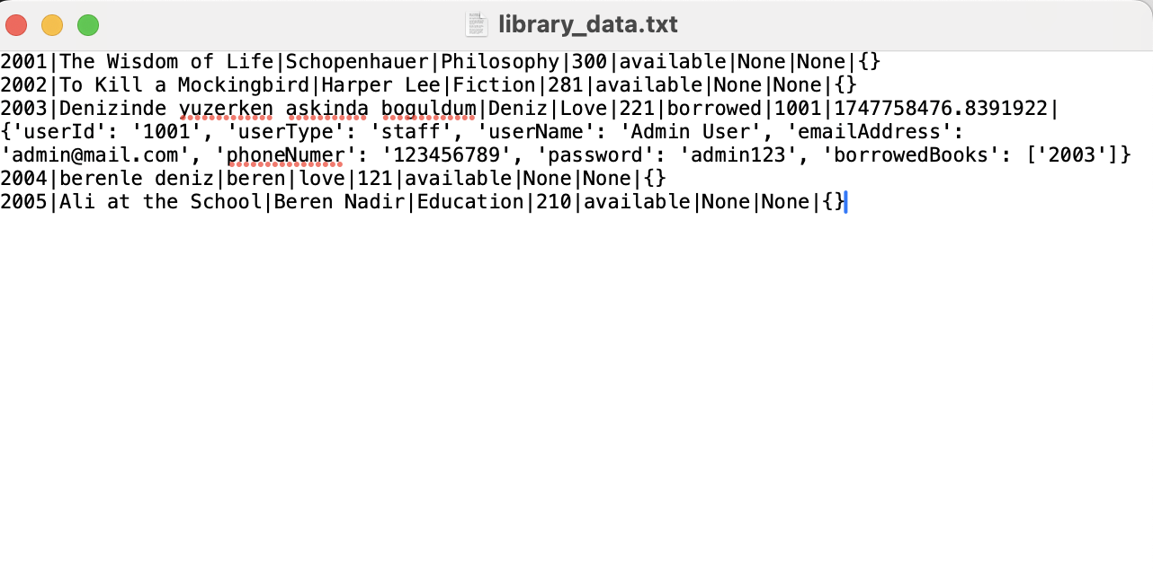
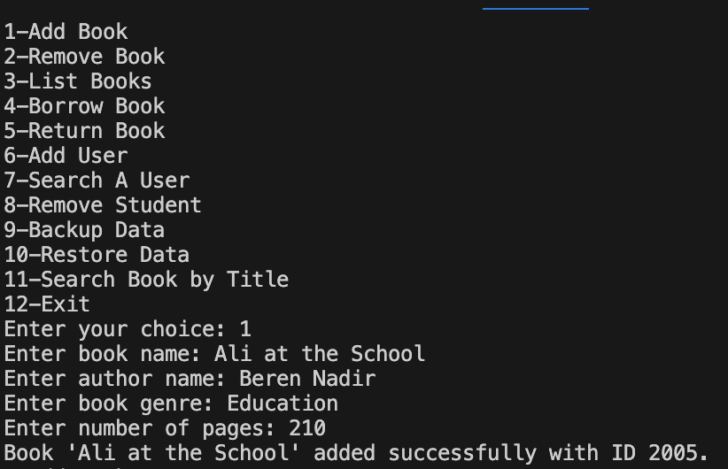

(Logged in as User(staff) and added a new book)

3.3 Borrowing a Book:
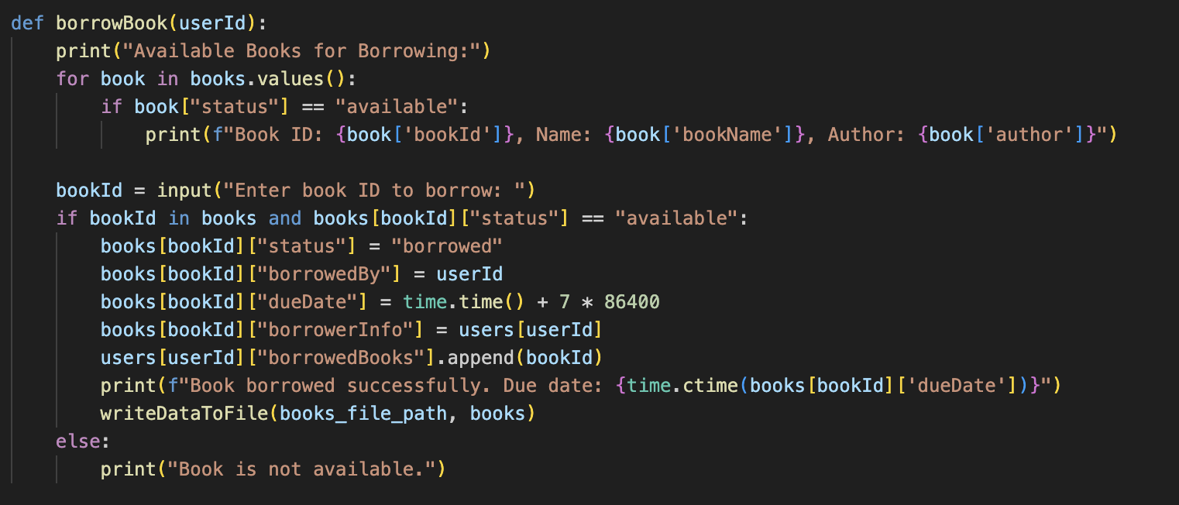

Figure 6: borrowBook (Source: Created by me)

borrowBook() lets a student or staff member check out a title.
First, it lists every book that is still marked available. The reader types the ID they want. If the ID is valid and the book is free, the code flips the book’s status to borrowed, stamps the borrower’s ID on it, and sets a due date exactly seven days ahead. It also drops that same book ID into the user’s personal “borrowedBooks” list, so both sides of the record agree. The updated information is saved straight back to library_data.txt so nothing is lost, and the program prints a friendly line telling the reader when to return the book. If the ID is wrong or somebody else already took it, the user simply gets a quick “not available” message.

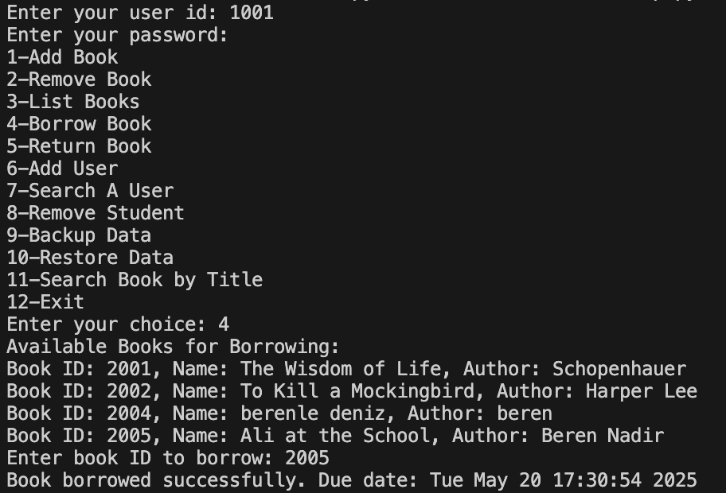
Output of borrowBook function:
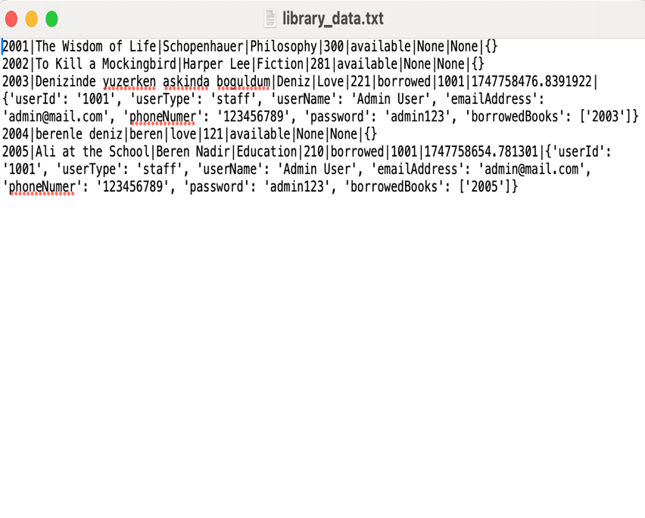

(First it lists the books which is available(not borrowed yet) then writes to the database with the date of borrowing)

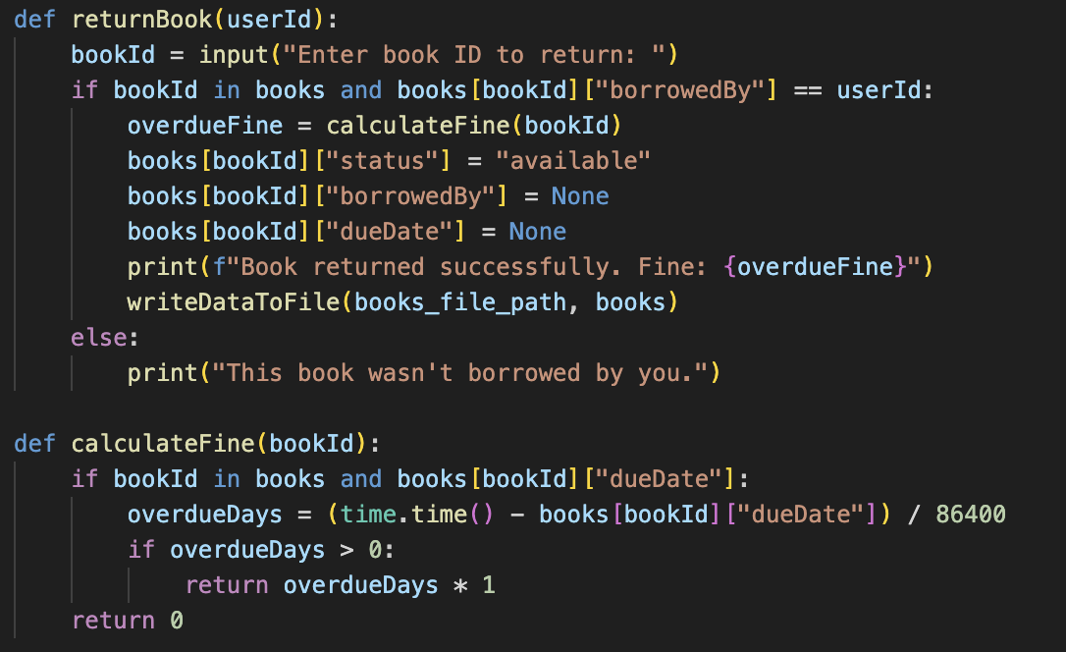
3.4 Returning the Book and Calculating the fine:

Figure 7: returnBook and calculateFine (Source: Created by me)

When a User wants to give a book back, returnBook() first checks that the ID they typed if it really belongs to them, so nobody can sneak a random return. If the match is good, it calls calculateFine() to see whether the book is late. That helper works by subtracting the stored dueDate from the current clock, every full day past the deadline costs one pound. Back in returnBook(), the code flips the book’s status to available, clears the borrower info, and saves the updated catalogue to the text file so nothing is lost. Finally, it prints a short note telling the user the book is safely returned and exactly how much, if anything, they owe.

Output of returnBook and calculateFine function:
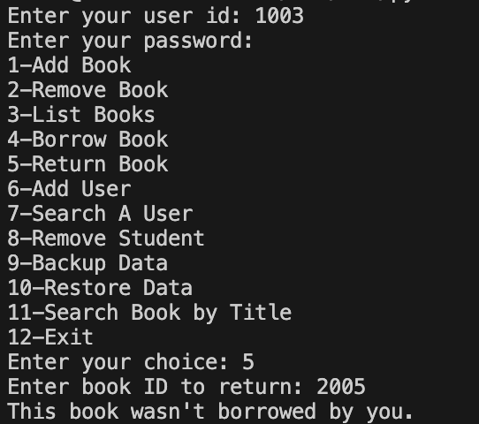
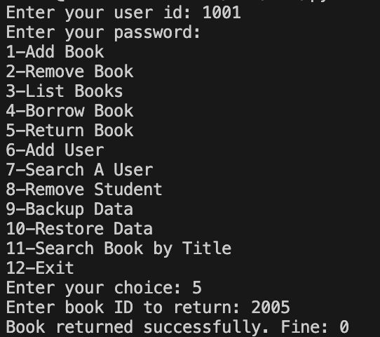

(First we logged in with a different Staff User ID and tried the return the book which wasn’t borrowed by us, system didn’t let us return it because it wasn’t our book, then logged in with the ID which was borrowed that specific book and we returned the book successfully. There’s no fine because we returned it in the same day we borrowed.)

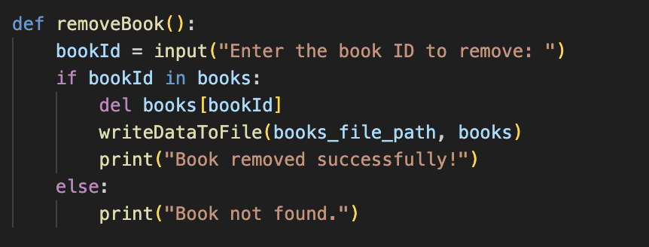
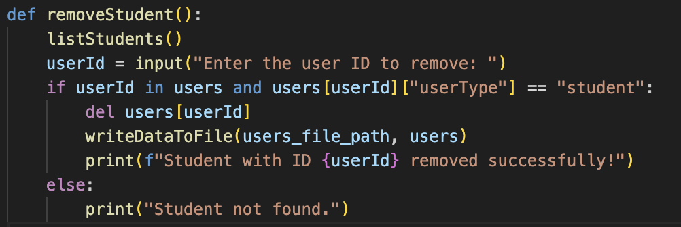
3.5 Removing Book & Removing Student

Figure 8: removeBook and removeStudent (Source: Created by me)

These two little blocks let the User wipe a record clean when it’s no longer needed. removeBook() asks for a book ID, checks if that ID is sitting in the books list, and if so simply deletes the entry, writes the trimmed list back to the file, and shows a quick “removed” line. If the number isn’t there, it just says “not found.” removeStudent() works the same way for student accounts: it shows the current student list, takes an ID, makes sure the person is marked as a student, then drops that user from the users list and saves the change. One short message confirms the job is done, or warns if the ID was wrong.

Output of removeBook and removeStudent function:
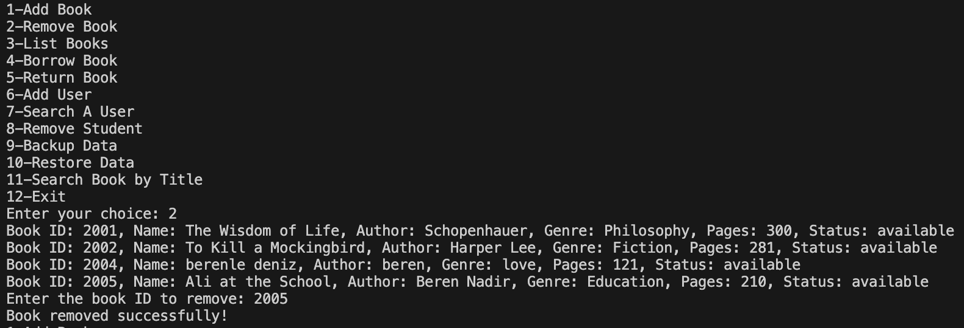

(First it lists all the books we have in the database then it allows you to remove it)
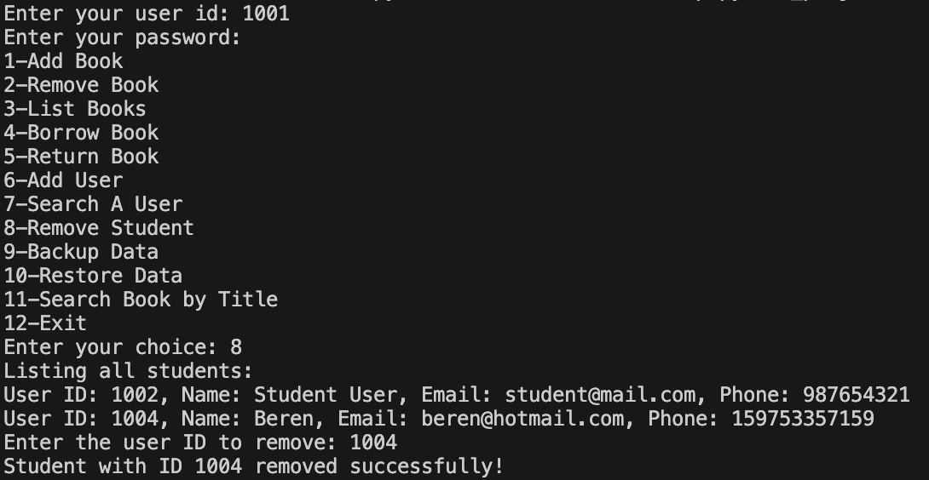

(First it lists all the students we have in the database then it allows you to remove it)

3.6 Listing the Books and their Borrowing Status
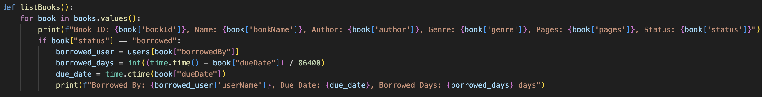

Figure 9: listBooks (Source: Created by me)

listBooks() walks through every entry in the books dictionary and prints a tidy summary line for each one book ID, title, author, genre, page count, plus whether the copy is available or already out. Whenever it spots a book marked borrowed, it adds a second, indented line that names the borrower, shows that person’s user ID, and spells out the exact due-back date in everyday calendar form. Because the loop covers the whole catalogue, the librarian can press a single menu key and instantly see the entire shelf, while students can check which titles are free and which are still in someone else’s backpack.

Output of listBooks() function:
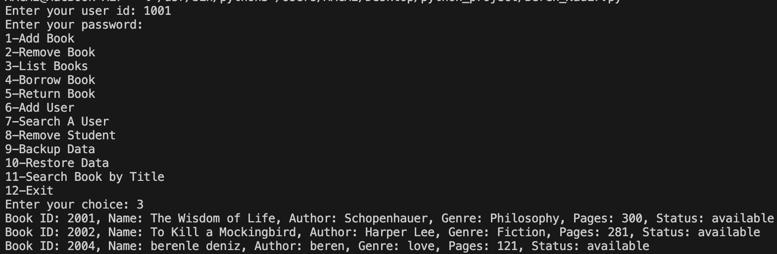
(It lists all the books we have in the database)

3.7 Search for Students and Books by typing
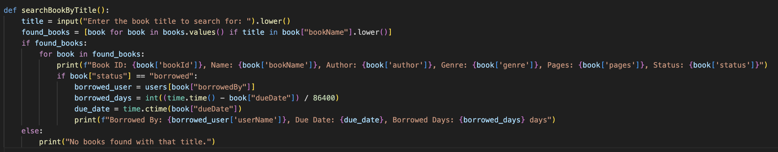
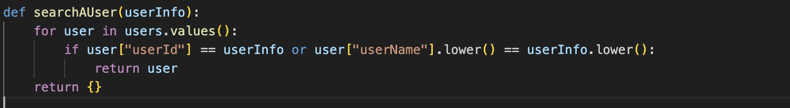

Figure 10: searchAUser & searchBookByTitle (Source: Created by me)

With searchAUser(), a librarian can type a full user ID or just part of a name. The function loops over every record in users ignores capital letter differences, and returns the first match it finds, if nothing matches, it simply hands back an empty result.
The partner helper, searchBookByTitle(), asks for a few letters from a book’s title, converts both the titles which is stored and the typed text to lower case, and selects every book that contains that fragment. For each hit it prints the ID, full title, author, and the book’s current status. If a copy is already out on loan, the routine also shows who borrowed it, when it’s due, and borrowed_days the whole day gap between right now and the due date. That number is work out by subtracting the stored dueDate from the current clock and dividing by 86.400 (seconds in a day). A positive value means the item is late by that many days, zero means it is due today, a negative value shows how many days are still left. With these two short searches, staff and students can locate people and books in seconds and see how close any loan is to being overdue.

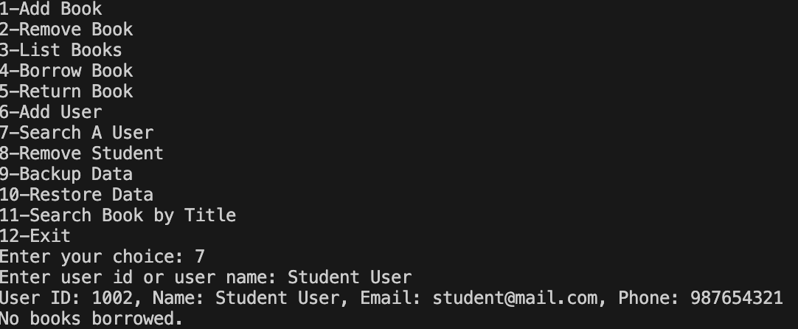
Output of searchAUser & searchBookByTitle() function:

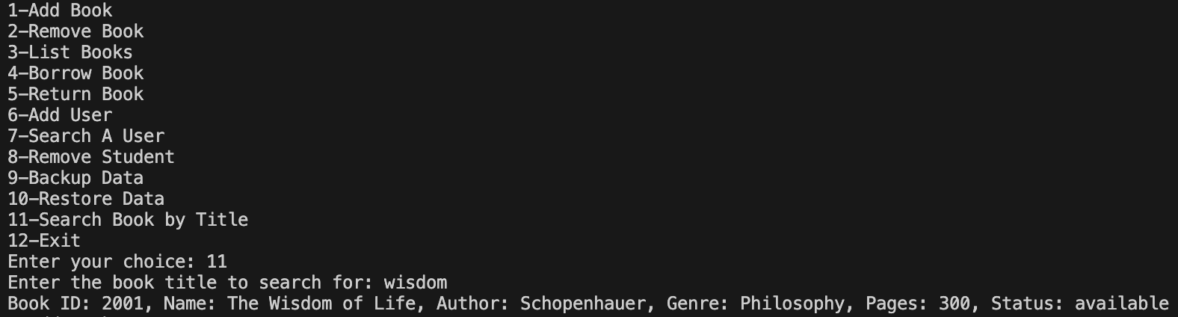
(If we write either their name or id, student will be shown with their full details but their password)

(If we write either just the books title or full name of the book it’ll be shown with it’s full details)

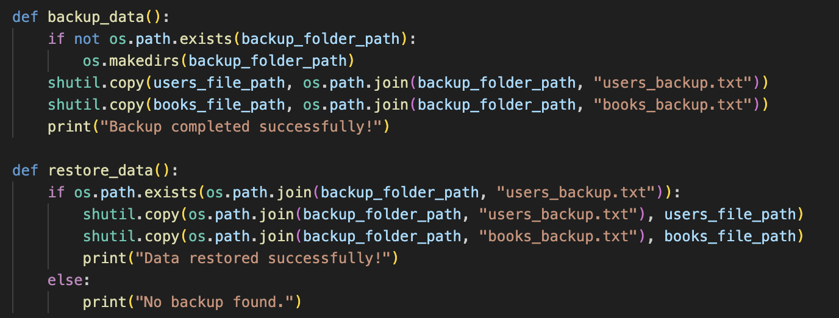
3.8 Backing up and Restoring the Data

Figure 11: backup_data & restore_data (Source: Created by me)

The two short functions above give the library a quick safety net. When you run backup_data(), the code looks for a folder named backups, if it doesn’t see one, it makes it on the spot. After that, it grabs the working copies of users.txt and library_data.txt and drops them into that folder under new names, users_backup.txt and books_backup.txt, so the originals stay where they are. A one-line “backup done” note pops up when the copy finishes. Later, if something goes wrong, restore_data() checks for those saved files and, when it finds them, copies them straight back over the live files. In a few seconds every user, book, and loan record is rolled back to the last safe point. If no backup exists, the program just says so instead of crashing.

Output of backup_data() & restore_data() function:
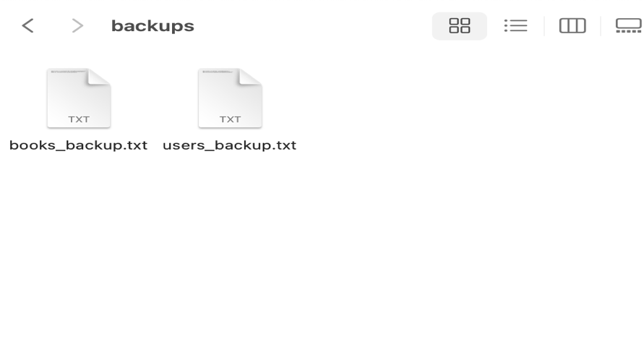
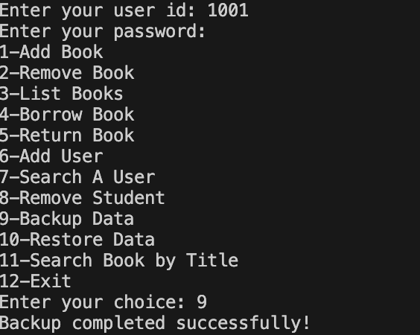
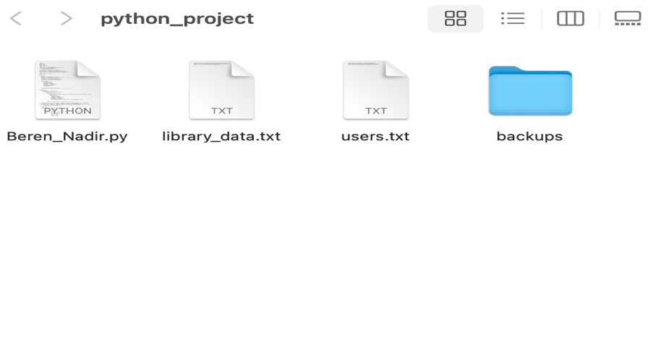

(By pressing 9 we backed up our current database as it shown above it created a file called backups)

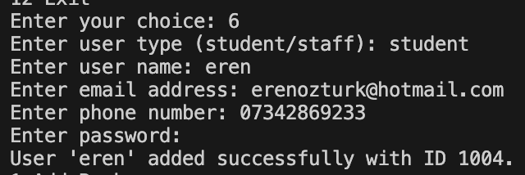
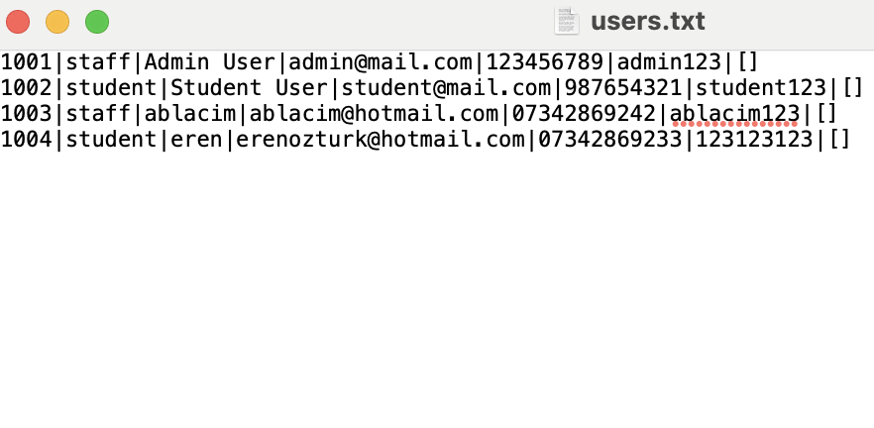

(Now we are adding a student to change the data and we’ll call 10 (restore data) to see if it’s going to bring our back up files)

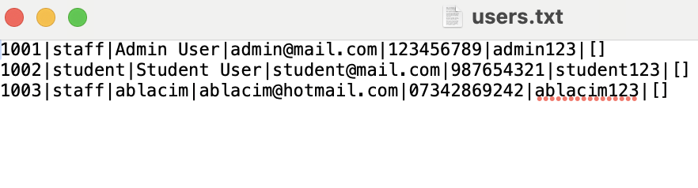
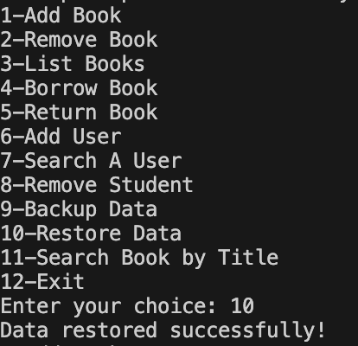

(Now we called 10 (restore data) and what we added recently it’s been gone, it restored the current data with our back_up one)

Student’s Interface:
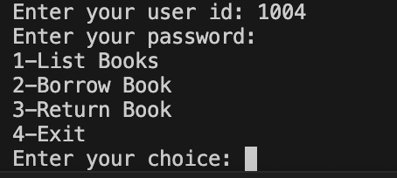
Figure 12: student interface (Source: Created by me)

The student side of the program is kept super simple on purpose. After a learner types their ID and password, the screen only shows four numbered picks: 1-List Books, 2-Borrow Book, 3-Return Book, 4-Exit. Nothing more, nothing hidden in sub-menus. That small menu means a new user can’t get lost— they either scan the shelf, grab a title, bring it back, or leave. Under the hood the code checks their role first (userType == "student") and skips every admin feature, so they can’t break things by accident. It also keeps them from deleting books or peeking at other people’s records, which is fair and safer. In short, the student interface is clean, fast, and gives exactly the actions a normal reader needs without drowning them in extra options.

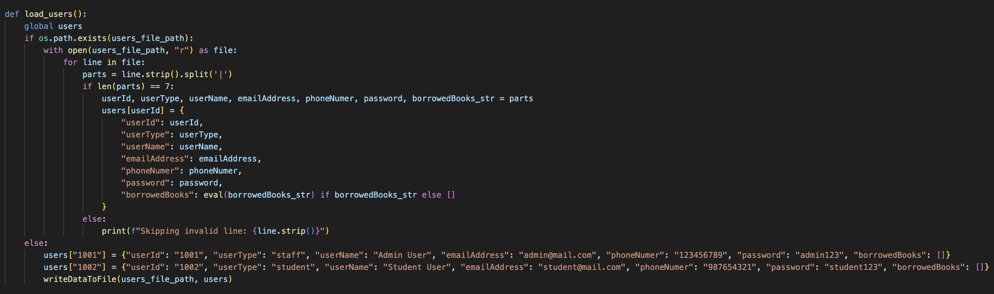
Data Loading Routine (users.txt & library_data.txt):
Figure 13: loading the users (Source: Created by me)

When the program boots, this bit digs around for users.txt. If the file is there, it reads each line, chops it into seven pieces, and drops the data into the big users dictionary. Any line that has the wrong number of pieces gets skipped, so one dodgy row doesn’t crash the app. If the file isn’t around (first run, or somebody deleted it), the code adds two starter accounts, one staff, one student, then saves them so the menu still works. Simple way to make sure the system always has at least one valid user and no blank screens.

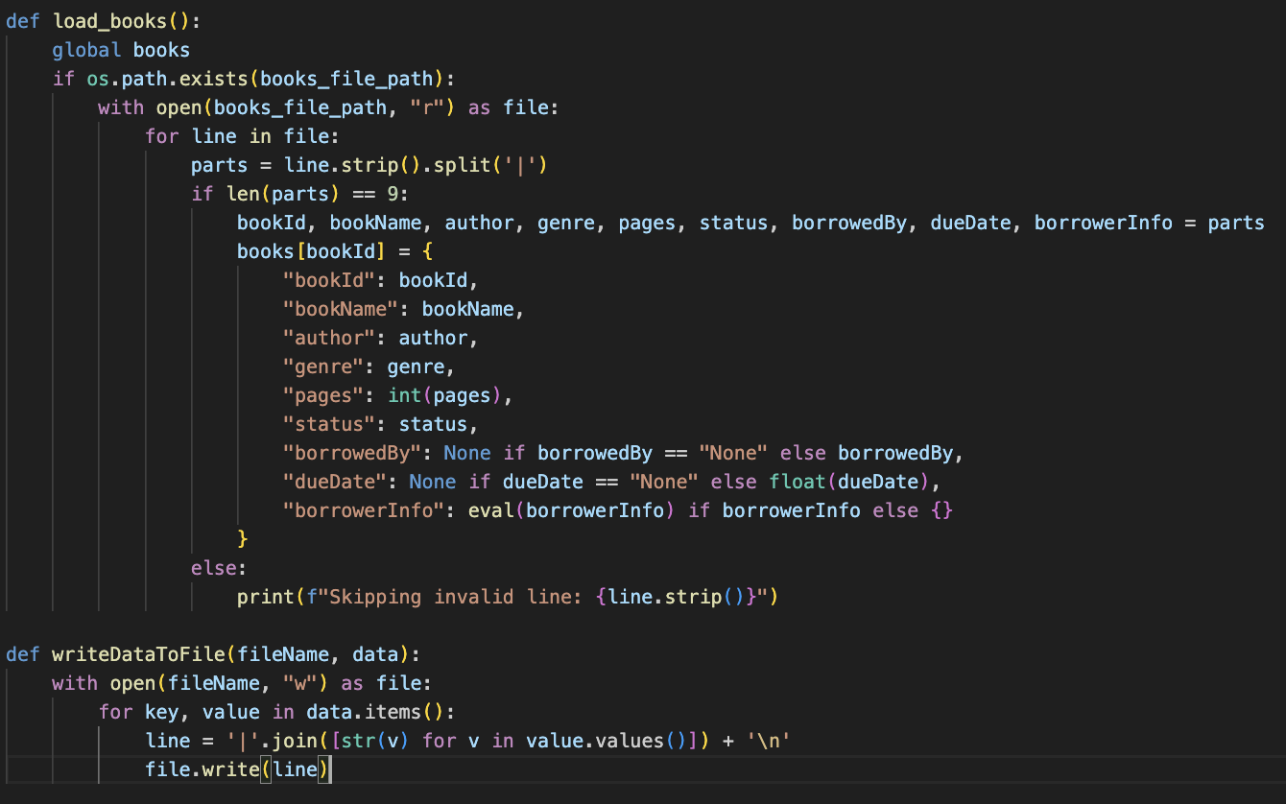
Figure 14: loading the books and writeDataToFile (Source: Created by me)

Same idea but for the shelf. The routine scans library_data.txt and, line by line, pushes each book into the books dictionary. It also converts the pages bit to an integer and the due-date text back to a float number so maths still works later. If the who field says “None,” we mark the book as not borrowed; otherwise, we remember which user ID holds it. Any weird-shaped row gets ignored with a small warning, so one type doesn’t nuke the whole list. End result, the catalogue is rebuilt in memory every time the program starts, ready for listing, borrowing, or returns. writeDataToFile() just takes whatever dictionary we’ve been editing in memory, turns each record into one long pipe-separated line, and drops the whole thing back into its text file so our changes don’t disappear next time we open the program.

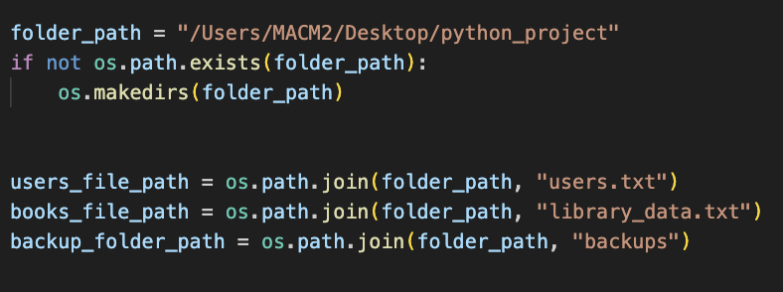
IMPORTANT(Data path)!

That location only exists on my own Mac. The code checks whether the folder is there and, if it is missing, makes it, then builds three file names under that same path (users.txt, library_data.txt, and a backups subfolder). If you copy the project onto another laptop or a lab computer, you must swap the string for a path that matches that machine—something like "C:\\LibraryApp" on Windows or "/home/yourname/python_project" on Linux. Otherwise Python will try to read and write in a spot that doesn’t exist, and every load-or-save call will throw a “No such file or directory” error.

Critics of Programme
Privacy & data use.
The program stores people’s names, emails, phone numbers, and even passwords, so there’s a clear privacy risk [1]. To reduce that, I collect the password through getpass, which hides what the user types [2]. I also keep the data in one folder that only the library PC should reach. A stronger fix for the next version would be hashing the password and moving the text files into an encrypted format [3], but masking the input was a first step.
Fair access.
Students and staff get different menu options: students can’t delete other users or books, which stops power abuse and keeps the system fair [3]. This role split is handled by a simple if aUser[“userType”] == “staff” check before showing the big admin menu.
Data loss & integrity.
Because everything lives in plain text, accidental deletion would normally be fatal. The backup_data() and restore_data() function let staff make a copy in one click and roll back just as fast [4], cutting the impact of user mistakes or a disk crash.
Transparency of fines.
Late-fee math is visible in the code, one pound per day, shown the moment the book is returned. That openness helps avoid disputes anyone can see how the number is calculated [5].
Ethical handling of errors.
Whenever the user types a wrong ID or tries to return a book they never borrowed, the program doesnt crash or silently fail, it prints a clear message explaining what went wrong [5]. This respectful feedback loop was added so users don’t feel blamed by vague errors.
Future improvements.
The next logical steps are encrypting stored passwords, logging who creates or deletes records(for accountability), and adding a short privacy notice so users know exactly what data is saved and why [4].

References
- European Union. (2016). Regulation (EU) 2016/679 of the European Parliament and of the Council of 27 April 2016 (General Data Protection Regulation). Official Journal of the European Union, L 119, 1-88. Retrieved 11 August 2024 from https://eur-lex.europa.eu
- Python Software Foundation. (2023). getpass — Portable password input. Python 3.11 Documentation. Retrieved 11 August 2024 from https://docs.python.org/3/library/getpass.html
- Saltzer, J. H., & Schroeder, M. D. (1975). The protection of information in computer systems. Communications of the ACM, 17(7), 388-402.
- International Organization for Standardization. (2022). ISO/IEC 27002:2022 — Information security, cybersecurity and privacy protection — Information security controls. Geneva: ISO.
- Nielsen, J. (1994). Enhancing the explanatory power of usability heuristics. In Proceedings of CHI ’94: Conference on Human Factors in Computing Systems (pp. 152-158). New York, NY: ACM.
- Sommerville, I. (2016). Software Engineering (10th ed.). Harlow, UK: Pearson.

